**International University**

School of Electrical Engineering

**Course Name**

**Course ID**

**Lab Title**

**Submitted by**

Team leader [Your name and Your ID number here]

Member: [Your name and Your ID number here]

Member: [Your name and Your ID number here]

Date Performed: [insert date]

Date Submitted: [insert date]

Lab Section: Lab 1

Course Instructor: M. Eng Nguyen Minh Thien

**GRADING CHECKLIST**

| **Number** | **Content** | **Satisfied?** | **Score** | **Comment** |
| --- | --- | --- | --- | --- |
| 1 | **Format (max 9%)** | |  |  |
| * Font type | Yes No |  |
| * Font size | Yes No |  |
| * Lab title | Yes No |  |
| * Page number | Yes No |  |
| * Table of contents | Yes No |  |
| * Header/Footer | Yes No |  |
| * List of figures (if exists) | Yes No |  |
| * List of tables (if exists) | Yes No |  |
| * Lab report structure | Yes No |  |
| 2 | **English Grammar and Spelling (max 6%)** | |  |  |
| * Grammar | Yes No |  |
| * Spelling | Yes No |  |
| 3 | **Data and Result Analysis (max 85%)** | |  |  |
| **Total Score** | |  | |  |

Date:

Signature

**TEAM CONTRIBUTION**

| **Task** | **[Team leader]** | **[Student 2]** | **[Student 3 if any]** |
| --- | --- | --- | --- |
| **Collaboration** | Organize workload | Proofread report | Proofread report, coordinate tasks… |
| **Lab preparation and experiment** | Set up equipment, test the circuits,  Answer in-class questions | Gather components, build the circuits,  Answer in-class questions | Record data, test the circuits  Answer in-class questions |
| **Data analysis** | Perform calculation | Perform simulations | Interpret and compare results |
| **Report writing** | Write fundamental background | Write experiment procedure | Write results and conclusion/discussion |

**Table of Contents**

List of Figures ........................................................................................….….............................. 3

List of Tables .................................................................................................……....................... 3

Discussion of Fundamentals.............................................................................................…….... 4

Experimental Procedure.............................................................................................……........... 4

Results ........................................................................................................……... 4

Conclusions………...................................................................................................................... 4

**List of Figures**

Figure 1 –………………………….……...…………………………………………………… x

Figure 2 – …………………………………………………………………..……………...….. x

Figure 3 – ……………………………………………………………………………………... x

Figure 4 –………………………………………….………………………..……………...….. x

Figure 5 – ……………………………………………………………………………………... x

Figure 6 – ……………............................................................................................................... x

**List of Tables**

Table 1 – ……………………………………..……………………........................................... x

Table 2 – ……………………………………..……………………........................................... x

Table 3 – ……………………………………..……………………........................................... x

**Discussion of Fundamentals**

In this section, describe the fundamental knowledge of the topic in this lab section. For example:

**If Selection Statement**

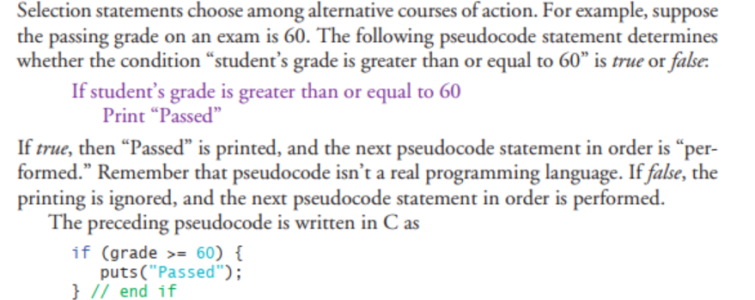

**Experimental Procedure**

Describe your problems here. Then, you should use flow chart or pseudo code to show your solution.

**Experimental Results**

In this section, you will paste your codes and the results here. The code section should be clean, easy to read, **font type Consolas, size 10**. For example:

Problem 1:

**#include <stdio.h>**

**int main(void)**

**{**

**//Variables decleration**

**int num1, rem1;**

**//Input processing**

**printf("Input an integer : ");**

**scanf("%d", &num1);**

**//Processing**

**rem1 = num1 % 2;**

**//Output Processing**

**if (rem1 == 0)**

**printf("%d is an even integer\n", num1);**

**else**

**printf("%d is an odd integer\n", num1);**

**}**

**Result**

*Figure 1. Result of the program in Problem 1 – Even/odd number checking.*

**Conclusion**

In the discussion, you should summarize your work in this lab.

Discuss the difficulties you have coped with and how you overcome them.

Emphasize and discuss the points that you consider to be important in this lab.

THE END